JSP Practical

JSP pages are used to develop dynamic responses.

Login Page

The program prompts user to enter student ID and password. The user is authorized if the student ID and password are in the database.

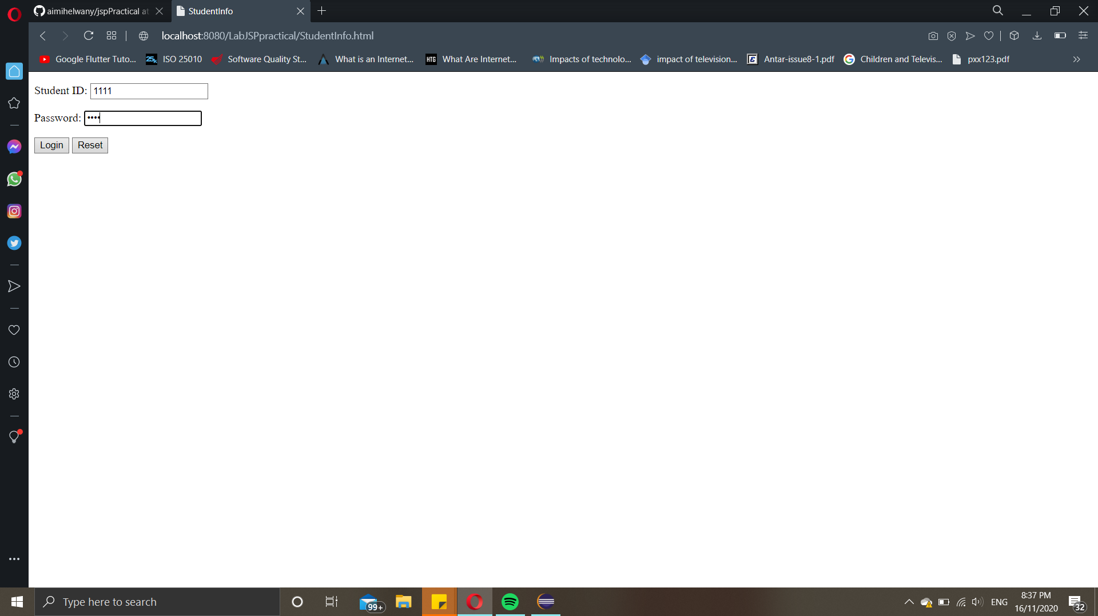

Student Info Page

The program display list of students with their details such as ID, name and department in a table.

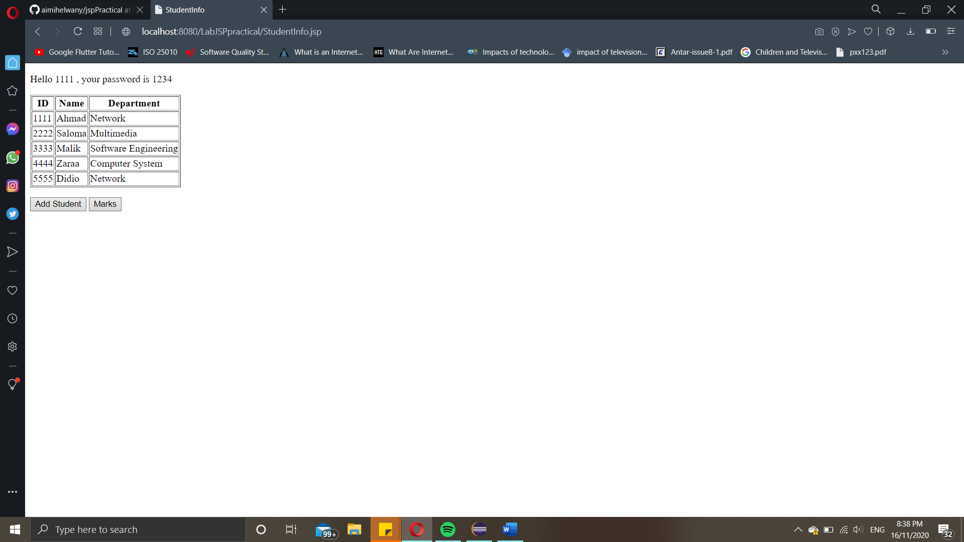

Marks Page

The program display list of students marks for subjects Science, English and Mathematics including the average marks for each student.

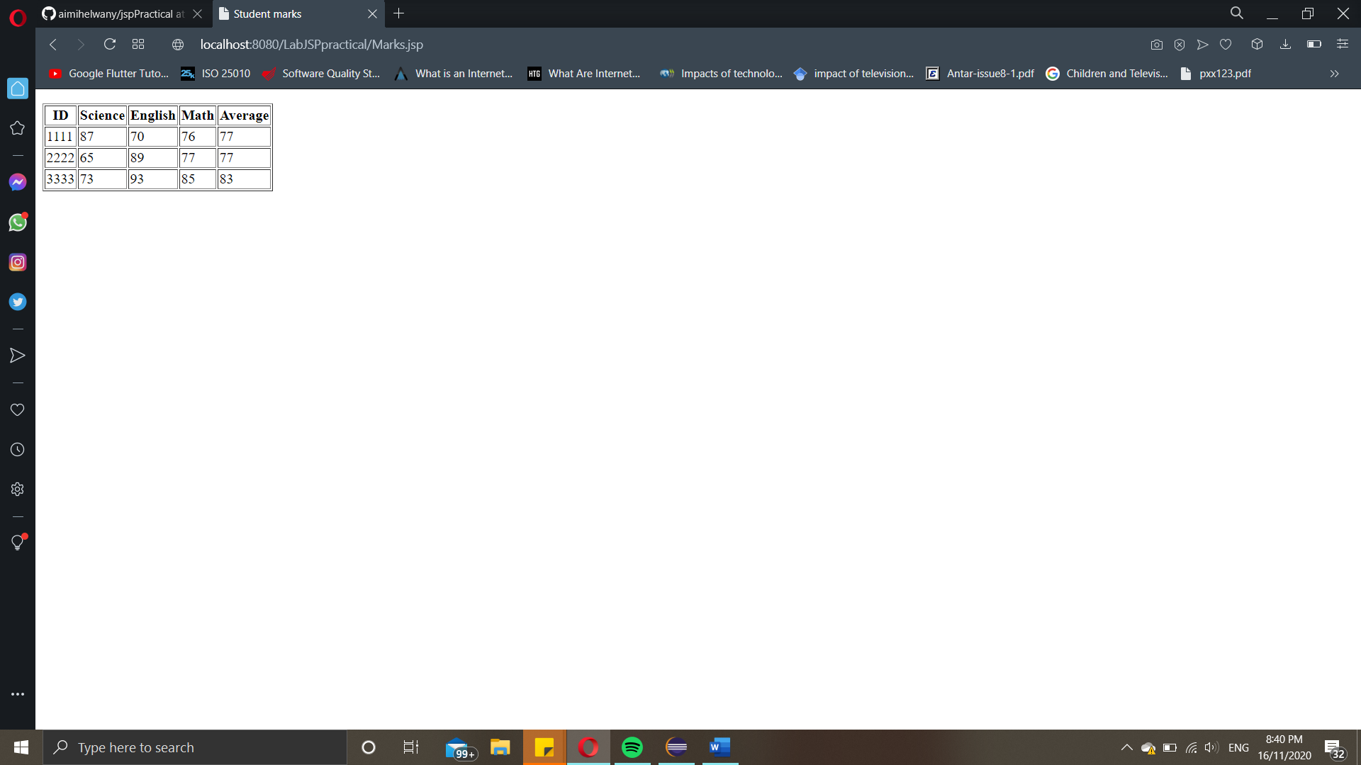

New Student Page

The program prompts user to enter new student information to be stored in database.

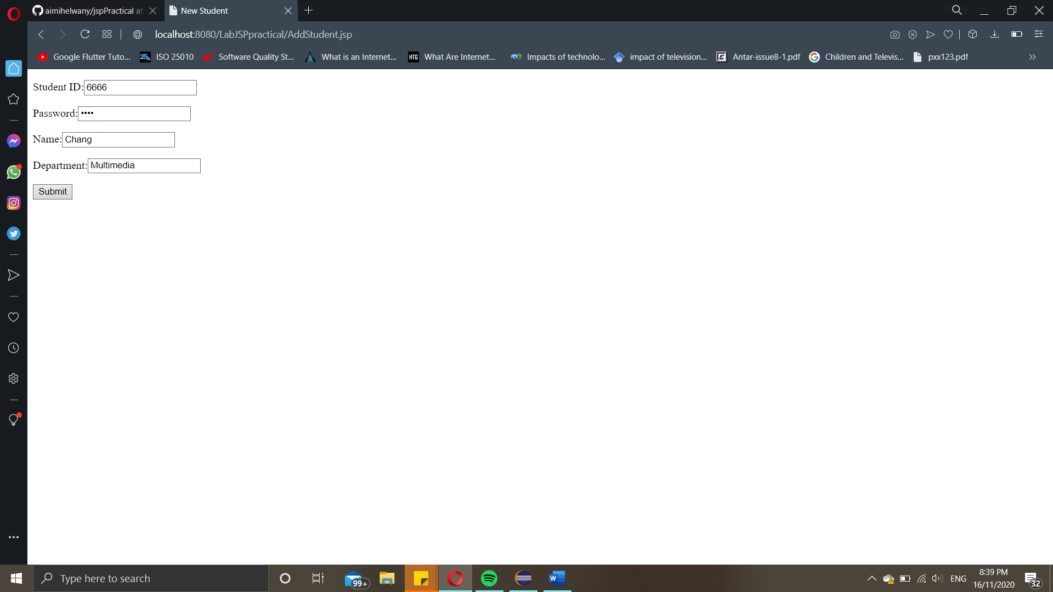

Status Page

The program displays the result whether the new student information successfully stored in the database or not.

